**Use case diagram**

Scenario-oriented description of expected functionality for the system

* Show “what” can be done (instead of “how” it works
* Don’t care about class, object, package, etc.
* Triggered by an actor
* UML syntax
  + **Actor**: anything external to the program that interacts with the program // **Use case**: Provides value to actors
  + Interaction // **Relationship between use cases**: include, extend, inheritance // **Relationship between actors**: inheritance

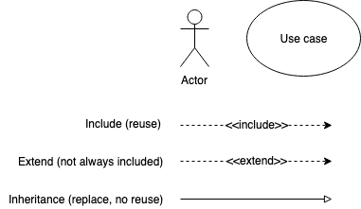

| **dt** | **Data** | **ps** | **Static** | **Dynamic** | **Integration** | **lod** | **sc** |
| --- | --- | --- | --- | --- | --- | --- | --- |
| Domain | x |  | x |  |  | l | sys |
| Use case |  |  |  |  | x | l | sys |
| Activity |  | x |  | x |  | m | uc |
| Robustness | x | x |  | x | x | h | uc |
| Sequence | x | x |  | x | x | h | uc |
| Data Flow | x |  |  | x |  | l | sys |

dt/data/ps/int/lod/sc=diagram type/-/-integration/level of disclosure/scope

sys/uc=system/use case

h/m/l = high/medium/low

**Use Case Description**

* Required: use case name, scenarious, alternatives
* Optional: purpose/objective, actors, preconditoins, postconditions, system behavior
* Always have actor and action

**Data Flow Diagrams**

* Not UML
* Shows how a system’s entities (external), processes, and storages (internal) are interconnected
* Syntax
  + Entity (People, roles, organizations, external systems, etc.)
  + Data flow (input, output)
  + Process
  + Storage (Databases, files, folders, etc.)
* Leveled
  + Level 0 (Context diagram) - system level (only one process, no storage) / Level 1 / etc.
* Rules
  + No direct link between nouns (entity, storage)
  + Storage introduced at level 1+ (not at context)
  + Process
* No black hole (all in, no out)/no white hole (no in, all out)

Add numbers to processes for tracking across levels (in the same level, no order)  
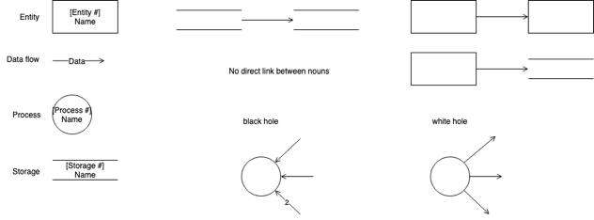

**Robustness Analysis/Design**

* Purposes

Identify objects (view, entities)/processes (controllers) needed to implement the use case

* Objects

**Actors** // **View/Interface** objects (What various actors use to interact with the system; e.g. pages, dialog boxes) // **Model/Entity** objects (temporary & persistent data that are used/generated by the system e.g. temporary data structures, database tables) // **Processes/Controller** object (To state loosely the ones that facilitate interactions between the above)

* Construction

**one diagram for each use case** // **created sentence-by-sentence from the text of the use case**

* Rules

**Actors can only talk to boundary objects** (Users can only deal with View objects) // **Boundary objects can only talk to controllers and actors**. (Views only talk with Users and controllers) // **Entity objects can only talk to controllers**. (Model objects can only talk with controllers) // **Controllers can talk to boundary objects, entity objects, and other controllers, but not to actors** (Controllers are always middleware and so don’t do anything outside the system)  
  
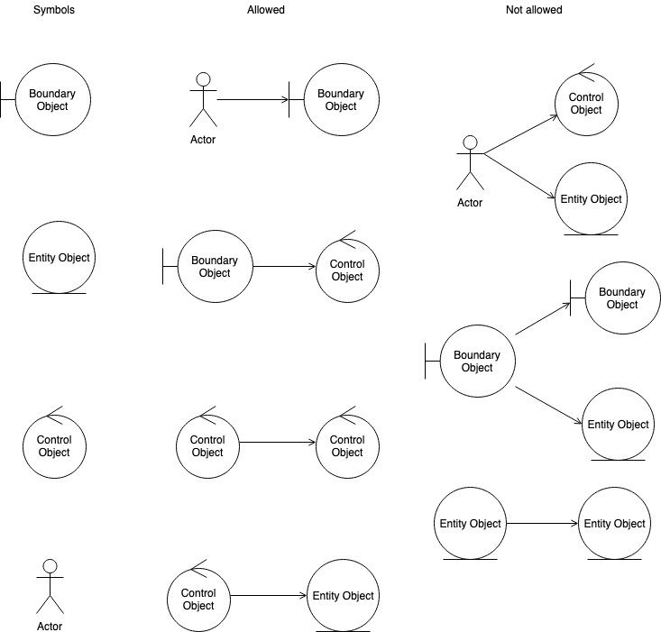

**Sequence Diagram**

* Purpose

**Help assign operations to classes/instances while drawing messages** // **Drive the detailed design - sequencing of assigned calls** // **Further refine set of required classes and operations needed**

* How

**One sequence diagram per use case** // **Both basic and alternate courses** // **Focus on behavior allocation**

[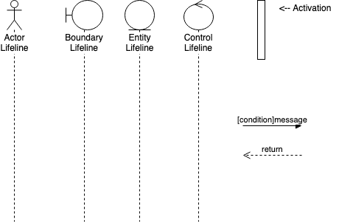](https://github.com/krishkalai07/SchoolWork/blob/master/CSS370/SequenceDiagramComponents.png)

**Class Design**

* class identification from project spec/requirements
* **nouns** are classes/objects/fields // **verbs** are potential methods or responsibilities of a class
* CRC card exercises

write **class name** on index card // next to each class, list the following **responsibilities**: problems to be solved (verb phrases) // **collaborators**: other classes that are sent messages by this class (asymmetric)

**Class Diagrams**

* **Definition:** a picture of the classes in an OO system, their fields and methods, and connections between the classes that interact or inherit from each other // not details of the class interaction / algorithmic details (behavior implementation)
* **Syntax: Class name** on top of box / <<interface>> above interface name / abstract class in italics // **attributes** (optional): all fields of object (- private) (+ public) (# protected) (/ ~ package-private) // **operation/methods** (optional) / may omit trivial methods (except from interface) / should not include inherited methods // **relationship between classes: generalization** (inheritance between classes / interface implementation) // **association** (dependency / aggregation / composition) / may include **multiplicity**